ASTON AND NECHELLS FOODBANK

We have been working hard over the past 6 months, to set up the Aston & Nechells Foodbank. This initiative has come from our desire to reach out to those in need in the local community – offering food in times of crisis as we believe Christ would want us to. Isn’t it shocking, that in this day and age, people in our communities struggle to put food on the table – and have to decide between food and heating? Last year Foodbanks fed over 60,000 people in just this situation, and we know that Aston & Nechells are full of folk who struggle to make ends meet.
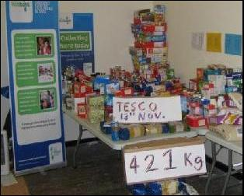
Our first lot of food came from our local schools and churches in their harvest celebrations – we were particularly blessed by the generosity of our link churches in Colwall and Dorridge.Since then, we have been working hard having monthly food collections at Tesco’s on the second Saturday of the month. The food is stored in warehouse facilities constructed and managed by Geoff Miller, with help from Winston, at St Matthew’s.

Food is distributed from the Salvation Army on a Friday and St Matthew’s on a Monday. Clients receive a warm Christian welcome, a cup of tea and a chat over their difficulties with one of our volunteers. They are signposted on to any other organisations that may be able to help them out of their crisis. Each family is given 3 days of food to carry away in supermarket bags.

Ricky, Olly and Rosemary have been working hard building contacts with local statutory and voluntary organisations. We are linked with social services, the children’s centres, mental health teams, neighbourhood offices and citizen’s advice bureaus, as well as health visitors and many others. This had been fun to develop – each of these agencies have their own vouchers that they can give to clients in need, who can then exchange them for the food.

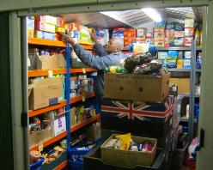
The Foodbank has been set up with the help and energy of Jenny – we are very grateful to her and will miss her enormously. She has a real passion for the poor and has enthused us! Thank you Jenny. Giyanow has done sterling work setting up our admin systems. There are many ways you can volunteer – why not help with our food collection at Tescos, or giving out food on Monday or Friday if you have time. Geoff always needs help in the warehouse and Giyanow with admin and PR. We welcome donations of food on Sunday at church – lists of foods required are available at all our churches. If you can help, please contact Giyanow, Ricky or Geoff and we will put you to work!!! Thank you so much to everyone who attended our volunteer day in October, and who have been faithfully serving in all the above ways. We love and appreciate you all!

